Question – 1 Write a program to print MySirG N times on the screen.

Ans.

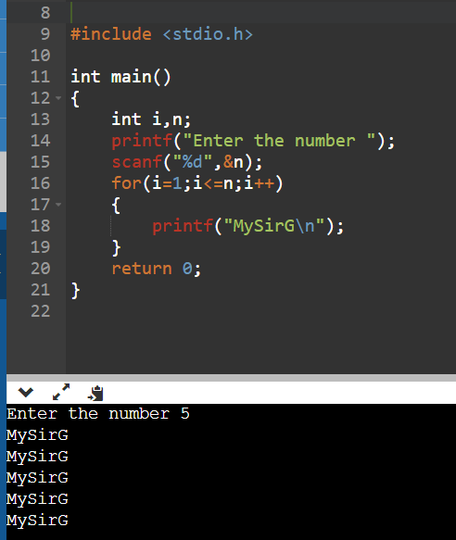

Question – 2 Write a program to print the first N natural numbers.

Ans.

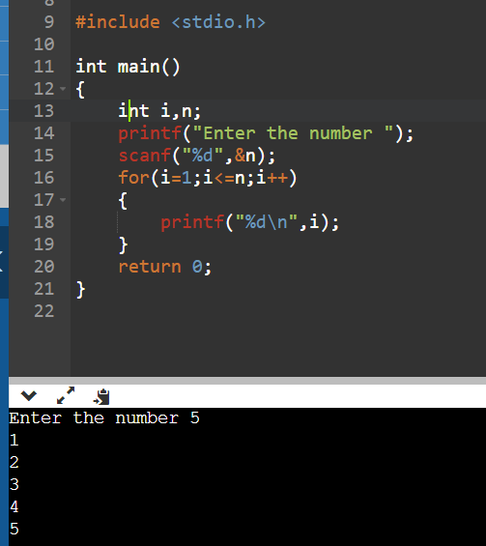

Question – 3 Write a program to print the first N natural numbers in reverse order.

Ans.

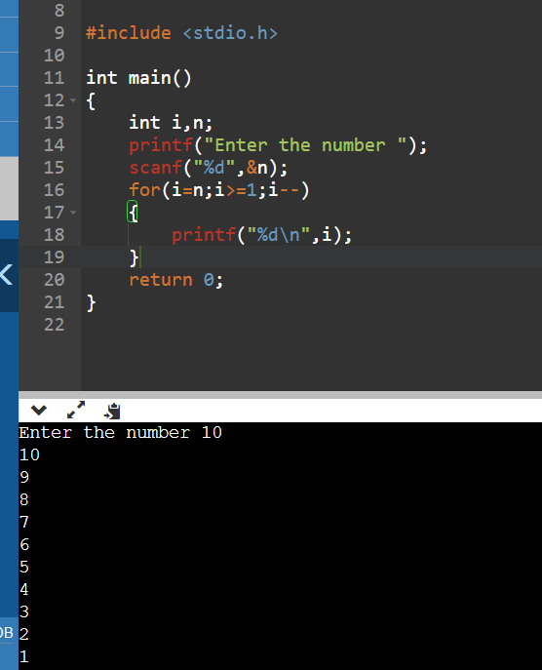

Question – 4 Write a program to print the first N odd natural numbers.

Ans.

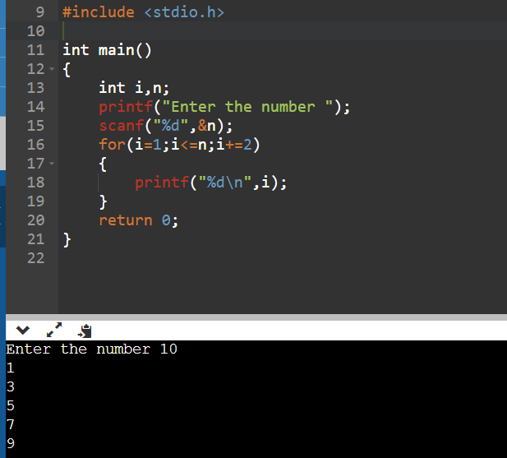

Question – 5 Write a program to print the first N odd natural numbers in reverse order.

Ans.

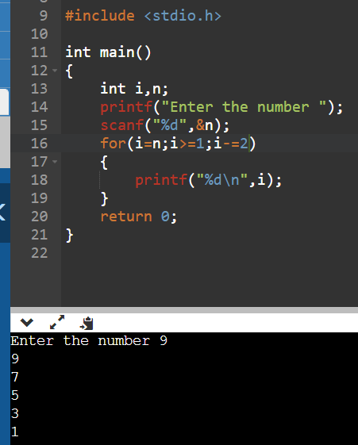

Question – 6 Write a program to print the first N even natural numbers.

Ans.

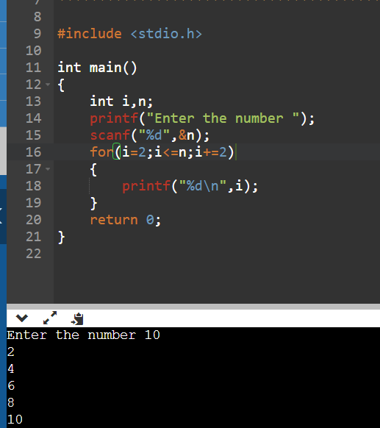

Question – 7 Write a program to print the first N even natural numbers in reverse order.

Ans.

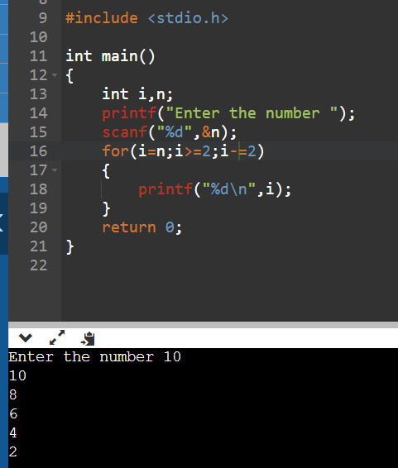

Question – 8 Write a program to print squares of the first N natural numbers.

Ans.

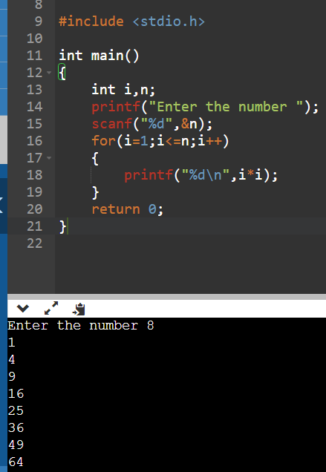

Question – 9 Write a program to print cubes of the first N natural numbers.

Ans

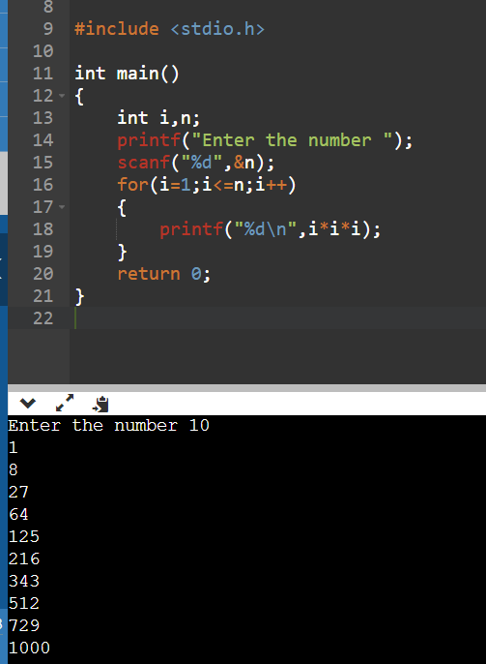

Question – 10 Write a program to print a table of N.

Ans.

